CAR RENTAL SYSTEM
L.Hebah Khojah

Student Name | Student ID
Rahaf Alsahli | 439201236
Joud bin derweesh | 439201031
Section Number:27891

- Introduction:
Our project is an application that help Employee to manage car rent system, The Employee can add new car to fleet,and make car rental(VIP or Economy) and fill customer information,and print bill after making rental.Thus,the Employee can return car from customer,and search about type(VIP or Economy). Finally,the application save all information to file when closing system

- Problem Definition:
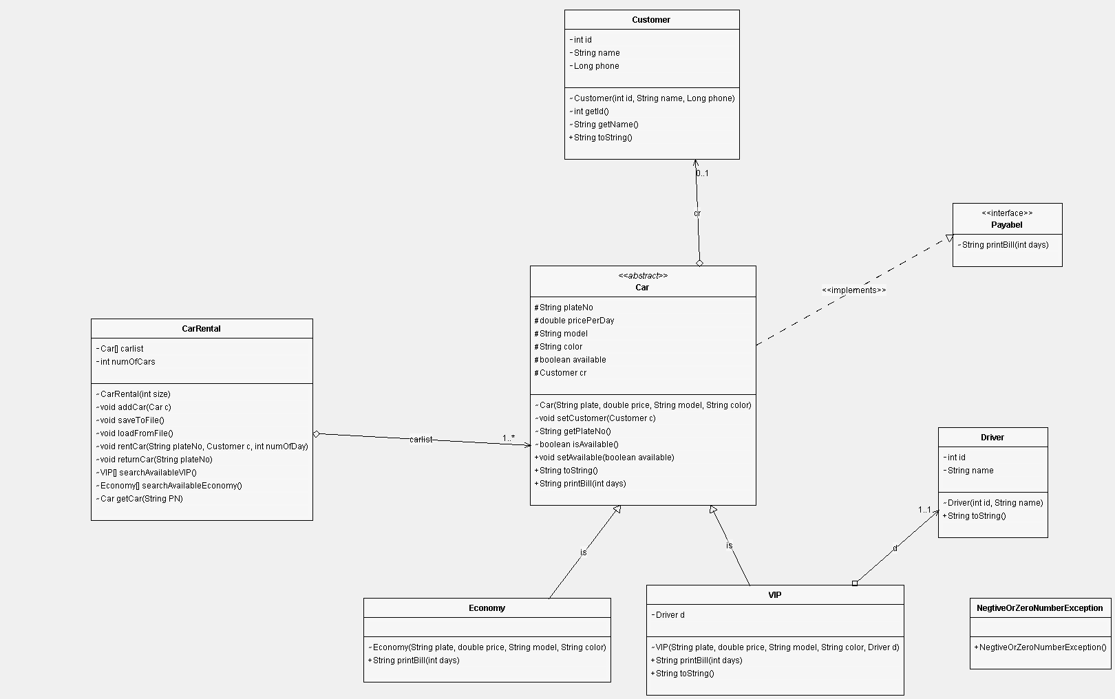

Class:VIP we add method toString that print the attributes of the class
- Test and Run:
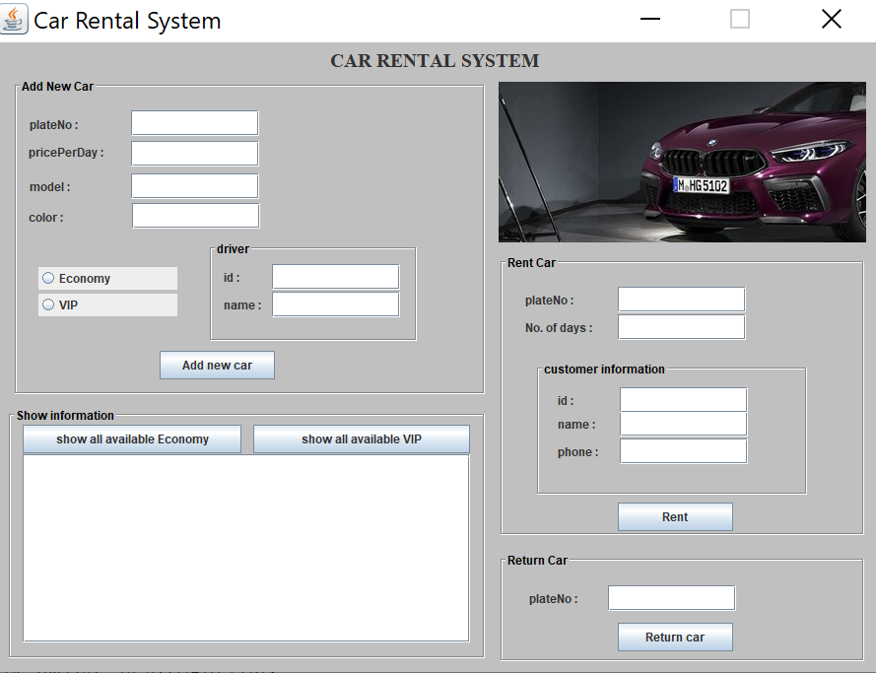
Figure 1:Home page

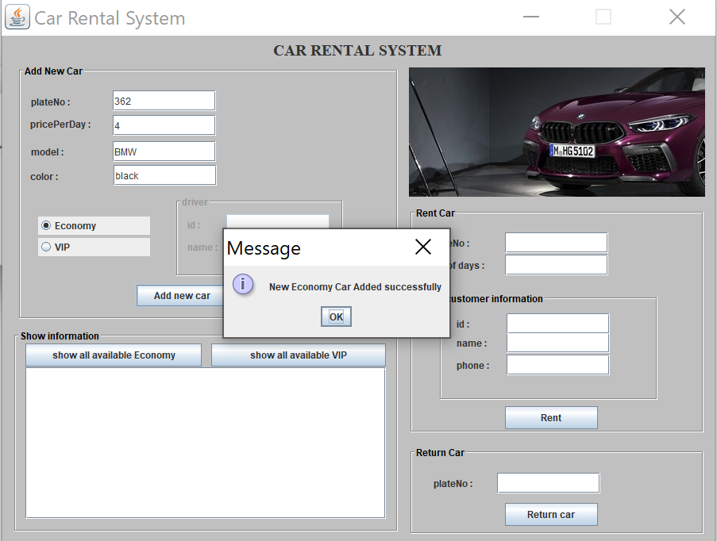
Figure 2:Message box that appears when adding new Car to system.

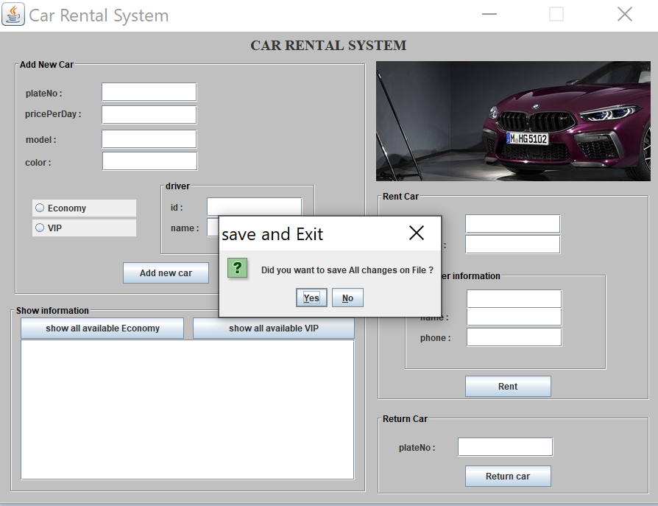
Figure 3:Message box that appears when closing the home frame.

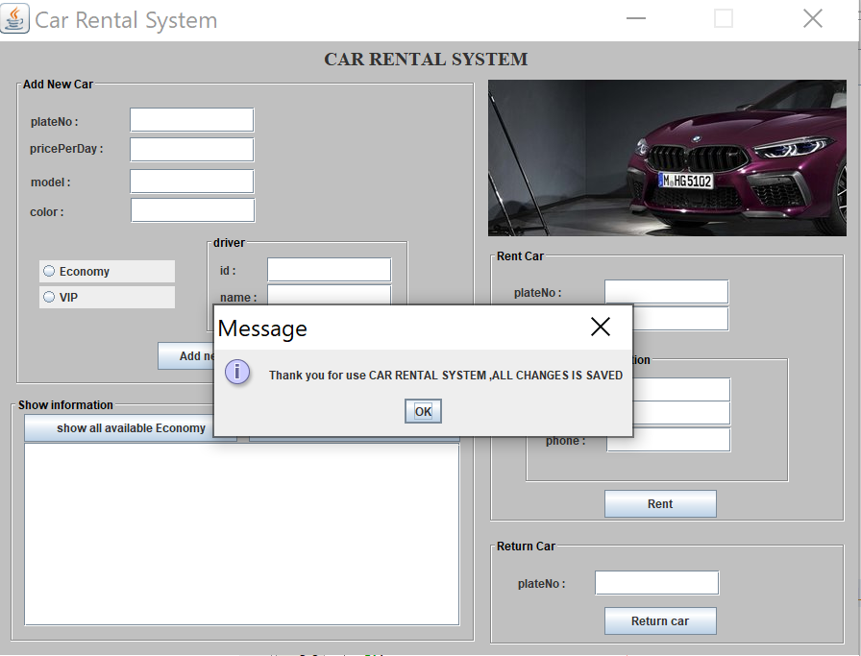
Figure 4:Message box that appears when choose yes to save data.

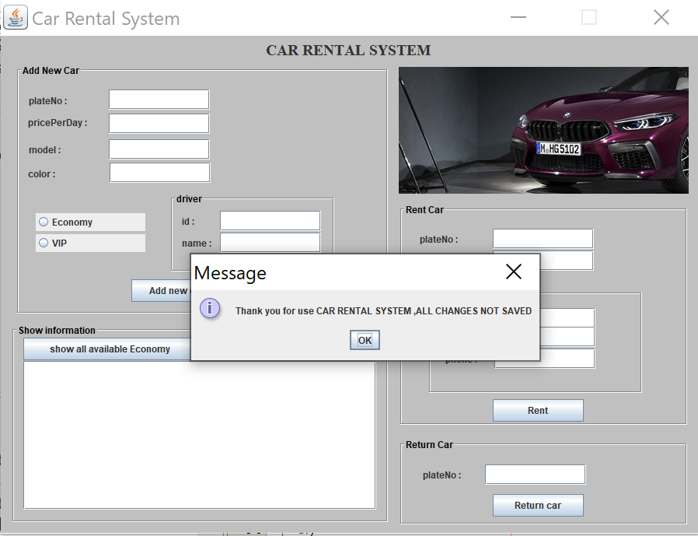
Figure 5:Message box that appears when choose No to save data.

- Implementation:
import java.awt.EventQueue;
import javax.swing.JFrame;
import java.awt.Color;
import javax.swing.JButton;
import java.awt.BorderLayout;
import java.awt.event.ActionListener;
import java.awt.event.WindowAdapter;
import java.awt.event.WindowEvent;
import java.io.FileNotFoundException;
import java.io.IOException;
import java.awt.event.ActionEvent;
import java.awt.GridLayout;
import java.awt.Image;
import javax.swing.JTextPane;
import java.awt.Font;
import javax.swing.DropMode;
import javax.swing.ImageIcon;
import java.awt.Label;
import java.awt.Toolkit;
import javax.swing.JLabel;
import javax.swing.JOptionPane;
import javax.swing.SwingConstants;
import javax.swing.JTextField;
import javax.swing.JPanel;
import javax.swing.border.TitledBorder;
import javax.swing.border.EtchedBorder;
import javax.swing.JRadioButton;
import javax.swing.JTabbedPane;
import javax.swing.JTextArea;
import javax.swing.JScrollPane;

public class RentalSystem {

private JFrame frmCarRentalSystem;
private JTextField textField;
private JTextField textField_1;
private JTextField textField_2;
private JTextField textField_3;
private JRadioButton rdbtnVip;
private JRadioButton rdbtnEconomy;
private JTextField textField_6;
private JTextField textField_7;
private JTextField textField_8;
private JTextField textField_9;
private JTextField textField_10;
private JTextField textField_11;
private JTextArea textArea;
private JTextField textField_4;
private JTextField textField_5;

public static void main(String[] args) {
EventQueue.invokeLater(new Runnable() {
public void run() {
try {
RentalSystem window = new RentalSystem();
window.frmCarRentalSystem.setVisible(true);
} catch (Exception e) {
e.printStackTrace();
}
}
});
}

public RentalSystem() {
initialize();

}

private void initialize() {

CarRental cr=new CarRental(100);

frmCarRentalSystem =new JFrame();
frmCarRentalSystem.setBackground(Color.LIGHT_GRAY);
frmCarRentalSystem.setTitle("Car Rental System");
frmCarRentalSystem.getContentPane().setBackground(Color.LIGHT_GRAY);
frmCarRentalSystem.getContentPane().setLayout(null);
frmCarRentalSystem.setResizable(false);

try {
cr.loadFromFile();
}catch(FileNotFoundException ex) {

}catch (ClassNotFoundException | IOException ex) {

JOptionPane.showMessageDialog(null,ex.getMessage()+" in load file");
}

frmCarRentalSystem.addWindowListener(new WindowAdapter(){
public void windowClosing(WindowEvent e) {

int x=JOptionPane.showConfirmDialog(null, "Did you want to save All changes on File ?","save and Exit",JOptionPane.YES_NO_OPTION);

if(x==JOptionPane.YES_OPTION)
try {
cr.saveToFile();
JOptionPane.showMessageDialog(null, "Thank you for use CAR RENTAL SYSTEM ,ALL CHANGES IS SAVED");

} catch (IOException ex) {
JOptionPane.showMessageDialog(null,ex.getMessage()+"in save file");
}

if(x==JOptionPane.NO_OPTION)
JOptionPane.showMessageDialog(null, "Thank you for use CAR RENTAL SYSTEM ,ALL CHANGES NOT SAVED");

}
});

JLabel lblCarRentalSystem = new JLabel("CAR RENTAL SYSTEM");
lblCarRentalSystem.setBounds(244, 6, 406, 32);
lblCarRentalSystem.setHorizontalAlignment(SwingConstants.CENTER);
lblCarRentalSystem.setFont(new Font("Times New Roman", Font.BOLD, 20));
lblCarRentalSystem.setVerticalAlignment(SwingConstants.TOP);
frmCarRentalSystem.getContentPane().add(lblCarRentalSystem);

JPanel panel_1 = new JPanel();
panel_1.setForeground(Color.BLACK);
panel_1.setBackground(Color.LIGHT_GRAY);
panel_1.setBorder(new TitledBorder(new EtchedBorder(EtchedBorder.LOWERED, null, null), "Add New Car", TitledBorder.LEADING, TitledBorder.TOP, null, new Color(0, 0, 0)));
panel_1.setBounds(19, 36, 481, 323);
frmCarRentalSystem.getContentPane().add(panel_1);
panel_1.setLayout(null);

JButton btnAddNewCar = new JButton("Add new car");
btnAddNewCar.setBounds(149, 277, 117, 29);
panel_1.add(btnAddNewCar);

JLabel lblPlateno = new JLabel("plateNo :");
lblPlateno.setBounds(17, 39, 61, 16);
panel_1.add(lblPlateno);

JLabel lblModel = new JLabel("model :");
lblModel.setBounds(17, 94, 113, 32);
panel_1.add(lblModel);

JLabel lblColor = new JLabel("color :");
lblColor.setBounds(16, 133, 61, 16);
panel_1.add(lblColor);

textField = new JTextField();
textField.setBounds(120, 33, 130, 26);
panel_1.add(textField);

textField_1 = new JTextField();
textField_1.setBounds(120, 64, 130, 26);
panel_1.add(textField_1);
textField_1.setColumns(10);

textField_2 = new JTextField();
textField_2.setBounds(120, 97, 130, 26);
panel_1.add(textField_2);
textField_2.setColumns(10);

rdbtnEconomy = new JRadioButton("Economy");
rdbtnEconomy.setBounds(26, 192, 141, 23);
panel_1.add(rdbtnEconomy);

rdbtnVip = new JRadioButton("VIP");
rdbtnVip.setBounds(26, 219, 141, 23);
panel_1.add(rdbtnVip);

textField_3 = new JTextField();
textField_3.setBounds(121, 127, 130, 26);
panel_1.add(textField_3);
textField_3.setColumns(10);

JLabel lblPriceperday = new JLabel("pricePerDay :");
lblPriceperday.setBounds(16, 59, 113, 32);
panel_1.add(lblPriceperday);

JPanel panel_2 = new JPanel();
panel_2.setBackground(Color.LIGHT_GRAY);
panel_2.setBorder(new TitledBorder(new EtchedBorder(EtchedBorder.LOWERED, null, null), "driver", TitledBorder.LEADING, TitledBorder.TOP, null, new Color(0, 0, 0)));
panel_2.setBounds(198, 165, 214, 104);
panel_1.add(panel_2);
panel_2.setLayout(null);

JLabel lblId = new JLabel("id :");
lblId.setBounds(16, 29, 61, 16);
panel_2.add(lblId);

JLabel lblName = new JLabel("name :");
lblName.setBounds(16, 57, 61, 16);
panel_2.add(lblName);

textField_4 = new JTextField();
textField_4.setBounds(65, 24, 130, 26);
panel_2.add(textField_4);
textField_4.setColumns(10);

textField_5 = new JTextField();
textField_5.setBounds(65, 52, 130, 26);
panel_2.add(textField_5);
textField_5.setColumns(10);
rdbtnVip.addActionListener(new ActionListener() {

public void actionPerformed(ActionEvent e) {
if(rdbtnVip.isSelected()) {
panel_2.setEnabled(true);
lblName.setEnabled(true);
lblId.setEnabled(true);
textField_4.setEnabled(true);
textField_5.setEnabled(true);
rdbtnEconomy.setSelected(false);

}

}

});
rdbtnEconomy.addActionListener(new ActionListener() {

public void actionPerformed(ActionEvent e) {
if(rdbtnEconomy.isSelected()) {
panel_2.setEnabled(false);
lblName.setEnabled(false);
lblId.setEnabled(false);
textField_4.setEnabled(false);
textField_5.setEnabled(false);
rdbtnVip.setSelected(false);

}
}

});
btnAddNewCar.addActionListener(new ActionListener() {

public void actionPerformed(ActionEvent e) {

try {

String plateNo,model,color,name;
double price;
int id;

if(textField.getText().isEmpty() || textField_1.getText().isEmpty() ||textField_2.getText().isEmpty() || textField_3.getText().isEmpty()) {
JOptionPane.showMessageDialog(null, "Empty input! please full it all");
return;}
plateNo=textField.getText();
price=Double.parseDouble(textField_1.getText());
model=textField_2.getText();
color=textField_3.getText();

if(price<=0)
throw new NegtiveOrZeroNumberException();

if(rdbtnVip.isSelected() && cr.getCar(plateNo)==null) {

if(textField_4.getText().isEmpty() || textField_5.getText().isEmpty()) {
JOptionPane.showMessageDialog(null, "Empty input! please full it all");
return;
}

id=Integer.parseInt(textField_4.getText());
name=textField_5.getText();

if(id<0)
throw new NegtiveOrZeroNumberException();

Driver d=new Driver(id,name);
cr.addCar(new VIP(plateNo,price,model,color,d));
else if(rdbtnEconomy.isSelected() && cr.getCar(plateNo)==null)
cr.addCar(new Economy(plateNo,price,model,color));
else
JOptionPane.showMessageDialog(null, "Can't add this car already in the list!")
}catch(NumberFormatException ex) {
JOptionPane.showMessageDialog(null, "invalid input! please enter it again ");
}catch(NegtiveOrZeroNumberException ex) {
JOptionPane.showMessageDialog(null, "invalid input! please enter it again ");
}finally {

textField.setText("");
textField_1.setText("");
textField_2.setText("");
textField_3.setText("");
textField_4.setText("");
textField_5.setText("");

}

}
});

JPanel panel_3 = new JPanel();
panel_3.setBackground(Color.LIGHT_GRAY);
panel_3.setBorder(new TitledBorder(new EtchedBorder(EtchedBorder.LOWERED, null, null), "Show information", TitledBorder.LEADING, TitledBorder.TOP, null, new Color(0, 0, 0)));
panel_3.setBounds(13, 370, 487, 257);
frmCarRentalSystem.getContentPane().add(panel_3);
panel_3.setLayout(null);

JButton btnShowAllAvailable = new JButton("show all available Economy");
btnShowAllAvailable.addActionListener(new ActionListener() {
public void actionPerformed(ActionEvent e) {
textArea.setText("");

Economy[] economy=cr.searchAvailableEconomy();

if(economy.length==0){
JOptionPane.showMessageDialog(null,"there is no avaliable Economy car");
return;
}
else
{
for(int i=0;i<economy.length;i++) {
textArea.append(economy[i].toString());
textArea.append("\n ________________________________________________________");
}
}

}
});
btnShowAllAvailable.setBounds(16, 18, 222, 29);
panel_3.add(btnShowAllAvailable);

JButton btnShowAllAvailable_1 = new JButton("show all available VIP");
btnShowAllAvailable_1.addActionListener(new ActionListener() {
public void actionPerformed(ActionEvent e) {
textArea.setText("");
VIP[] vip=cr.searchAvailableVIP();
if(vip.length==0){
JOptionPane.showMessageDialog(null,"there is no avaliable VIP car");
return;
}
else
for(int i=0;i<vip.length;i++) {
textArea.append(vip[i].toString());
textArea.append("\n _______________________________________________________");
}

}
});
btnShowAllAvailable_1.setBounds(250, 18, 220, 29);
panel_3.add(btnShowAllAvailable_1);

textArea = new JTextArea();
textArea.setFont(new Font("Lucida Grande", Font.PLAIN, 11));
textArea.setBounds(16, 48, 454, 191);
panel_3.add(textArea);

JScrollPane scrollPane = new JScrollPane(textArea);
scrollPane.setBounds(16, 48, 454, 191);
panel_3.add(scrollPane);

JLabel lblNewLabel = new JLabel("");
ImageIcon img = new ImageIcon(Toolkit.getDefaultToolkit().getImage(getClass().getResource("car2.jpg")));
Image img1 = img.getImage();
ImageIcon i = new ImageIcon(img1);
lblNewLabel.setIcon(i);

lblNewLabel.setBounds(512, 40, 373, 163);
frmCarRentalSystem.getContentPane().add(lblNewLabel);

JPanel panel_4 = new JPanel();
panel_4.setBackground(Color.LIGHT_GRAY);
panel_4.setBorder(new TitledBorder(new EtchedBorder(EtchedBorder.LOWERED, null, null), "Rent Car", TitledBorder.LEADING, TitledBorder.TOP, null, new Color(0, 0, 0)));
panel_4.setBounds(512, 215, 373, 287);
frmCarRentalSystem.getContentPane().add(panel_4);
panel_4.setLayout(null);

JLabel lblPlateno_1 = new JLabel("plateNo :");
lblPlateno_1.setBounds(27, 38, 61, 16);
panel_4.add(lblPlateno_1);

JLabel lblNoOfDays = new JLabel("No. of days :");
lblNoOfDays.setBounds(27, 66, 94, 16);
panel_4.add(lblNoOfDays);

textField_6 = new JTextField();
textField_6.setBounds(121, 33, 130, 26);
panel_4.add(textField_6);
textField_6.setColumns(10);

textField_7 = new JTextField();
textField_7.setBounds(121, 61, 130, 26);
panel_4.add(textField_7);
textField_7.setColumns(10);

JPanel panel_5 = new JPanel();
panel_5.setBackground(Color.LIGHT_GRAY);
panel_5.setBorder(new TitledBorder(new EtchedBorder(EtchedBorder.LOWERED, null, null), "customer information", TitledBorder.LEADING, TitledBorder.TOP, null, new Color(0, 0, 0)));
panel_5.setBounds(37, 108, 278, 138);
panel_4.add(panel_5);
panel_5.setLayout(null);

JLabel lblId_1 = new JLabel("id :");
lblId_1.setBounds(23, 32, 61, 16);
panel_5.add(lblId_1);

JLabel lblName_1 = new JLabel("name :");
lblName_1.setBounds(23, 56, 61, 16);
panel_5.add(lblName_1);

JLabel lblPhone = new JLabel("phone :");
lblPhone.setBounds(23, 84, 61, 16);
panel_5.add(lblPhone);

textField_8 = new JTextField();
textField_8.setBounds(86, 27, 130, 26);
panel_5.add(textField_8);
textField_8.setColumns(10);

textField_9 = new JTextField();
textField_9.setBounds(86, 51, 130, 26);
panel_5.add(textField_9);
textField_9.setColumns(10);

textField_10 = new JTextField();
textField_10.setBounds(86, 79, 130, 26);
panel_5.add(textField_10);
textField_10.setColumns(10);

JButton btnRent = new JButton("Rent");
btnRent.setBounds(121, 252, 117, 29);
panel_4.add(btnRent);

JPanel panel_6 = new JPanel();
panel_6.setBackground(Color.LIGHT_GRAY);
panel_6.setBorder(new TitledBorder(new EtchedBorder(EtchedBorder.LOWERED, null, null), "Return Car", TitledBorder.LEADING, TitledBorder.TOP, null, new Color(0, 0, 0)));
panel_6.setBounds(512, 517, 373, 113);
frmCarRentalSystem.getContentPane().add(panel_6);
panel_6.setLayout(null);

JLabel lblPlateno_2 = new JLabel("plateNo :");
lblPlateno_2.setBounds(31, 39, 61, 16);
panel_6.add(lblPlateno_2);

textField_11 = new JTextField();
textField_11.setBounds(111, 34, 130, 26);
panel_6.add(textField_11);
textField_11.setColumns(10);

JButton btnReturnCar = new JButton("Return car");
btnReturnCar.addActionListener(new ActionListener() {
public void actionPerformed(ActionEvent e) {

String plateNo="";

if(textField_11.getText().isEmpty()) {
JOptionPane.showMessageDialog(null,"enter all fields"); }
else{
plateNo=textField_11.getText();

}
cr.returnCar(plateNo);
textField_11.setText("");

}
});
btnReturnCar.setBounds(121, 72, 117, 29);
panel_6.add(btnReturnCar);
frmCarRentalSystem.setBounds(100, 100, 903, 690);
frmCarRentalSystem.setDefaultCloseOperation(JFrame.EXIT_ON_CLOSE);
btnRent.addActionListener(new ActionListener() {

public void actionPerformed(ActionEvent e) {

String plateNo,name;
int numOfDay,id;
long phone;

if(textField_6.getText().isEmpty() || textField_7.getText().isEmpty() || textField_8.getText().isEmpty() || textField_9.getText().isEmpty() || textField_10.getText().isEmpty()) {
JOptionPane.showMessageDialog(null, "Empty input! please full it all");
return;
}
plateNo=textField_6.getText();
numOfDay=Integer.parseInt(textField_7.getText());

try {
id=Integer.parseInt(textField_8.getText());
name=textField_9.getText();
phone=Long.parseLong(textField_10.getText());

if(id<0)
throw new NegtiveOrZeroNumberException();

Customer c=new Customer(id,name,phone);

try {
cr.rentCar(plateNo, c, numOfDay);
} catch (IOException ex) {
JOptionPane.showMessageDialog(null,ex.getMessage());
}
}catch(NumberFormatException ex) {
JOptionPane.showMessageDialog(null, "invalid input! please enter enter it again ");
}catch(NegtiveOrZeroNumberException ex) {
JOptionPane.showMessageDialog(null, "invalid input! please enter enter it again ");
}finally {

textField_6.setText("");
textField_7.setText("");
textField_8.setText("");
textField_9.setText("");
textField_10.setText("");

}

}
});
}
}
Format of Report:
- Paper Size: A4 size paper
- Line Spacing: 1.5 line
- Font size: Times New Roman, Heading (bold /14 pt), paragraph (12 pt).

